Web Technology &It’s Applications

Program-4: Develop and demonstrate a HTML5 file that includes JavaScript script that uses functions for the following problems:

1. Parameter: A string
2. Output: The position in the string of the left-most vowel
3. Parameter: A number
4. Output: The number with its digits in the reverse order

Code:

<!DOCTYPE HTML>

<html>

<head><title>Program-4</title></head>

<body>

<script type="text/javascript">

var str = prompt("Enter the Input", "");

if (!(isNaN(str))) //isNaN means is Not a Number

{

var num, rev = 0,remainder; num = parseInt(str);

while (num != 0)

{

remainder = num % 10; num = parseInt(num / 10);

rev = rev * 10 + remainder;

}

alert("Reverse of " + str + " is " + rev);

}

else

{

str = str.toUpperCase();

for (var i = 0; i < str.length; i++) //0,1,2,3

{

var chr = str.charAt(i);

if (chr == 'A' || chr == 'E' || chr == 'I' || chr == 'O' || chr == 'U') break;

}

if (i < str.length)

alert("The position of the left most vowel is " + (i + 1)); else

alert("No vowel found in the entered string");

}

</script>

</body>

</html>

Output 1:

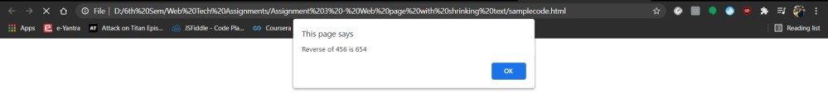

Output 2:

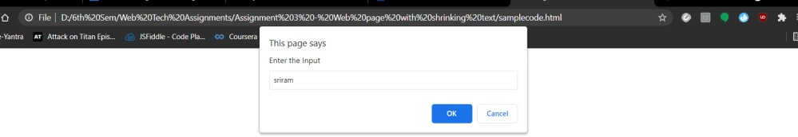

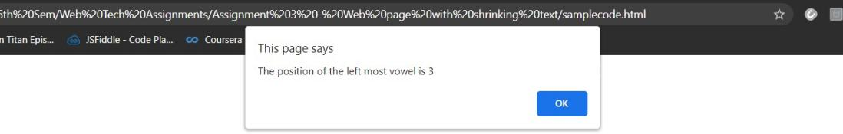

Test cases:

|  |  |  |  |
| --- | --- | --- | --- |
| Case  No. | Test case | Expected output | Obtained output |
| 1 | Integer value: 456 Text value: abc | Reverse of 456 is 654. The position of the  left most vowel is 1 | Reverse of 456 is 654. The position of the left  most vowel is 1 |
| 2 | Negative value: -159 Test value: varun | Reverse of –159 is –  951.  The position of the  left most vowel is 2 | Reverse of –159 is –  951.  The position of the left  most vowel is 2 |
| 3 | Integer Value:753  Non vowel string:  bcdf | Reverse of 753 is 357. No vowel found in the  entered string. | Reverse of 753 is 357. No vowel found in the  entered string. |
| 4 | Integer Value: 1564  Alpha numerical  value: 456as | Reverse of 1564 is 4651. The position of the  left most vowel is 4. | Reverse of 1564 is 4651. The position of the left  most vowel is 4. |

Challenge program Code:

<!DOCTYPE HTML>

<html>

<head><title>Program-4</title></head>

<body>

<script type="text/javascript">

var str = prompt("Enter the Input", "");

if (!(isNaN(str)))

{

var num, num2, rev = 0, remainder;

num = parseInt(str);

num2 = num;

while (num != 0)

{

remainder = num % 10;

num = parseInt(num / 10);

rev = rev * 10 + remainder;

}

product = num2 * rev;

alert("Reverse of " + str + " is " + rev);

alert("product of " + num2 + " and " + rev + " is " + product);

}

else

{

str = str.toUpperCase();

var count = 0;

for (var j = 0; j < str.length; j++)

{

var chr = str.charAt(j);

if (chr == 'A' || chr == 'E' || chr == 'I' || chr == 'O' || chr == 'U')

{

    count=count+1;

}

}

alert("The number of vowels are " + count);

for (var i = 0; i < str.length; i++)

{

var chr = str.charAt(i);

if (chr == 'A' || chr == 'E' || chr == 'I' || chr == 'O' || chr == 'U')

{

    break;

}

}

if (i < str.length)

alert("The position of the left most vowel is " + (i + 1));

else

alert("No vowel found in the entered string");

}

</script>

</body>

</html>

Output:

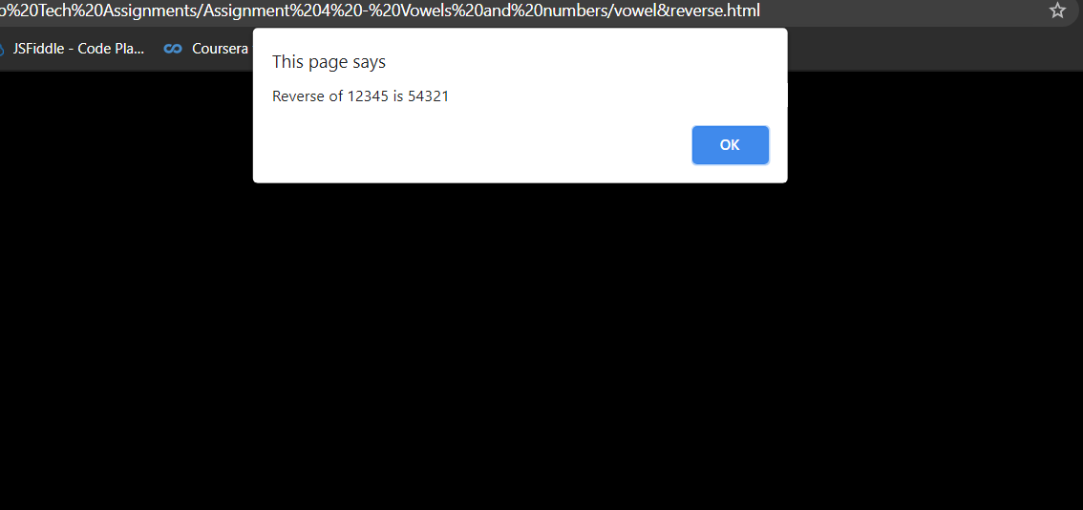

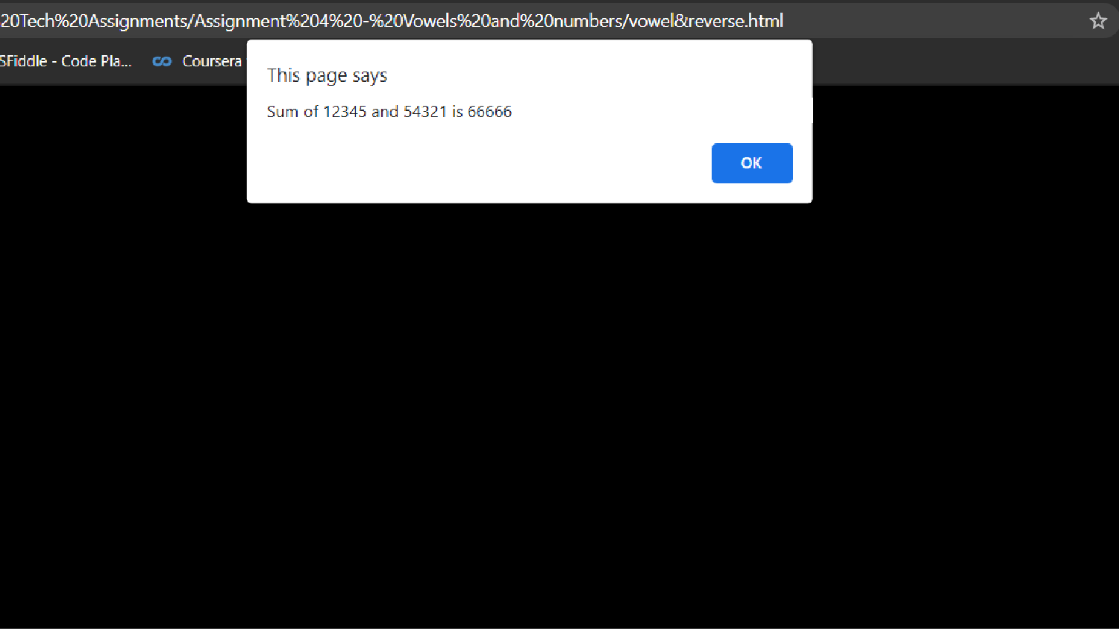



The number of vowels are 2







This page says

The position of the left most vowel is 3

Test Cases:

|  |  |  |  |
| --- | --- | --- | --- |
| Case  No. | Test case | Expected output | Obtained output |
| 1 | Integer value: 456. Text value: abc | Reverse of 456 is 654. product of 456 and  654 is 298224.  The position of the left most vowel is 1. The number of  vowels is 1. | Reverse of 456 is 654.  product of 456 and 654 is  298224.  The position of the left most vowel is 1.  The number of vowels is  1. |
| 2 | Negative value: -123 Test value: sriram | Reverse of –123 is –  321. product of –123 and –321 is 39483. The position of the left most vowel is 3. The number of  vowels is 2. | Reverse of –123 is –321.  product of –123 and –321 is  39483.  The position of the left most vowel is 3.  The number of vowels is  2. |
| 3 | Integer Value: 789 Non vowel string: bcdf | Reverse of 789 is 987. product of 789 and  987 is 778743.  No vowel found in  the entered string. | Reverse of 789 is 987.  product of 789 and 987 is  778743.  No vowel found in the  entered string. |
| 4 | Integer Value: 248 Alpha numerical value: 12as | Reverse of 248 is 842. product of 248 and  842 is 208816.  The position of the left most vowel is 3. The number of  vowels is 1. | Reverse of 248 is 842.  product of 248 and 842 is  208816.  The position of the left most vowel is 3.  The number of vowels is  1. |